**React JS:**

**What is react?**

**React** is a JavaScript library for building user interfaces and open source library.

The web pages (also known as views in this context) typically loads inline within the same page itself.

**Where else should you use Reactjs?**

Of course, we can’t cover each-and-every use-case of Reactjs in a single article. The list is endless, but here’s a taste of some example web apps

What is React (or Reactjs) and how it works?

React is defined as a JavaScript library that makes the process painless for creating interactive user interfaces. It was created by Jordan Walke, a software engineer at Facebook, and first deployed on Facebook’s News Feed in 2011. It’s used for single-page or mobile application development.

An open-source & component-based front-end library, ReactJS is ‘V’ in MVC. This implies that it is responsible only for the view layer of the application.

To get things done faster, React implements a virtual DOM, which is a DOM tree representation in Javascript. At its core, React maintains a tree, which is able to do efficient different computations on the nodes. It also enables you to re-construct DOM in Javascript and push those changes to the DOM which have actually occurred.

Who created React?

The developers at Facebook created React because they wanted to move out of the world of HTML based web apps. Currently, React is maintained and contributed by a large community of developers, from Instagram, Wix, etc. to name a few.

where you can use Reactjs:

* Business websites
* Portfolios
* Forums
* Rating websites
* Membership sites
* eLearning modules
* Galleries
* Q&A websites like Quora
* Non-profit websites for collecting donations
* Wikis and knowledge bases
* Media-centric sites like YouTube
* Auction and coupon sites

What’s the difference between Real DOM and Virtual DOM in React?

* The DOM (Document Object Model) is an object-oriented representation of a web page that can be modified with a scripting language like Javascript. DOM represents the document in terms of nodes and objects. This way, programming languages can connect to the page. With DOM, programmers can build documents, navigate their structure, and add, modify, or delete elements and content.
* The Virtual DOM is a representation of a DOM object such as a lightweight copy. One thing, which makes React and its Virtual DOM unique is it is simpler than the other approaches to making Javascript reactive.
* React uses one-way data binding to make things simpler. For example, every time you type in an input field in a React UI, then it does not directly change the state of that component. Rather than, it updates the data model that causes the UI to be updated, and the text which you typed into the field appears in the field

What is Reactjs used for?

React JS can be used to build various types of applications. For example Dashboards or data visualization tools, Single-page websites, Social networks, Media Sites, Video platforms, Marketplaces, eCommerce, and Sharing economy platforms.

Create React App:

Npx create:react-app projectname

Cd projectname

Run command: npm start

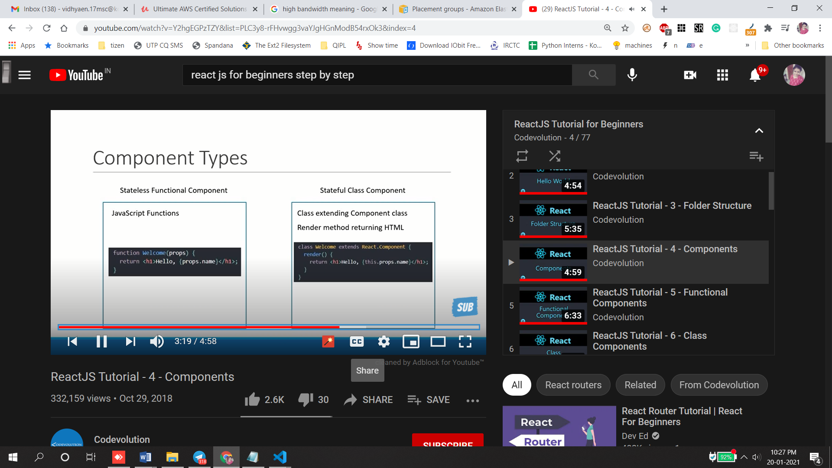

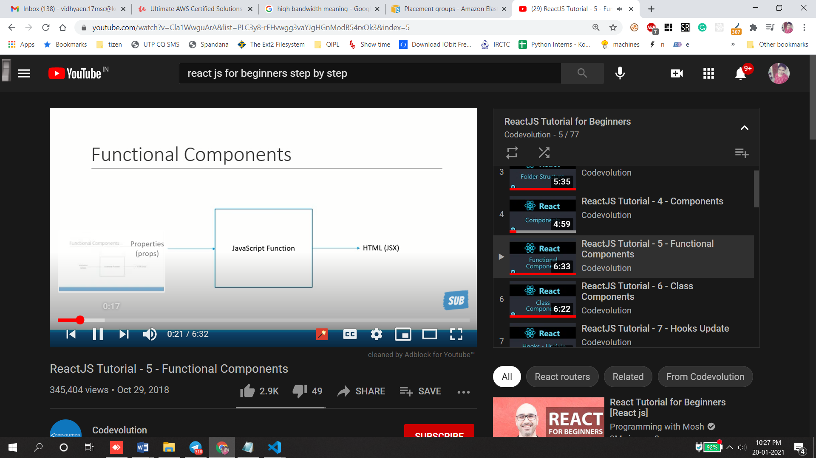

1)export const Greet = () => <h1>Function</h1>

import {Greet} from './components/Greet'

function App() {

  return (

    <div className="App">

      <Greet/>

      <Welcome/>

      <Hi/>

    </div>

  );

}

2) import Hi from './components/Hi'

class Hi extends Component {

    render(){

        return <h1>Class components</h1>

    }

}

export default Hi

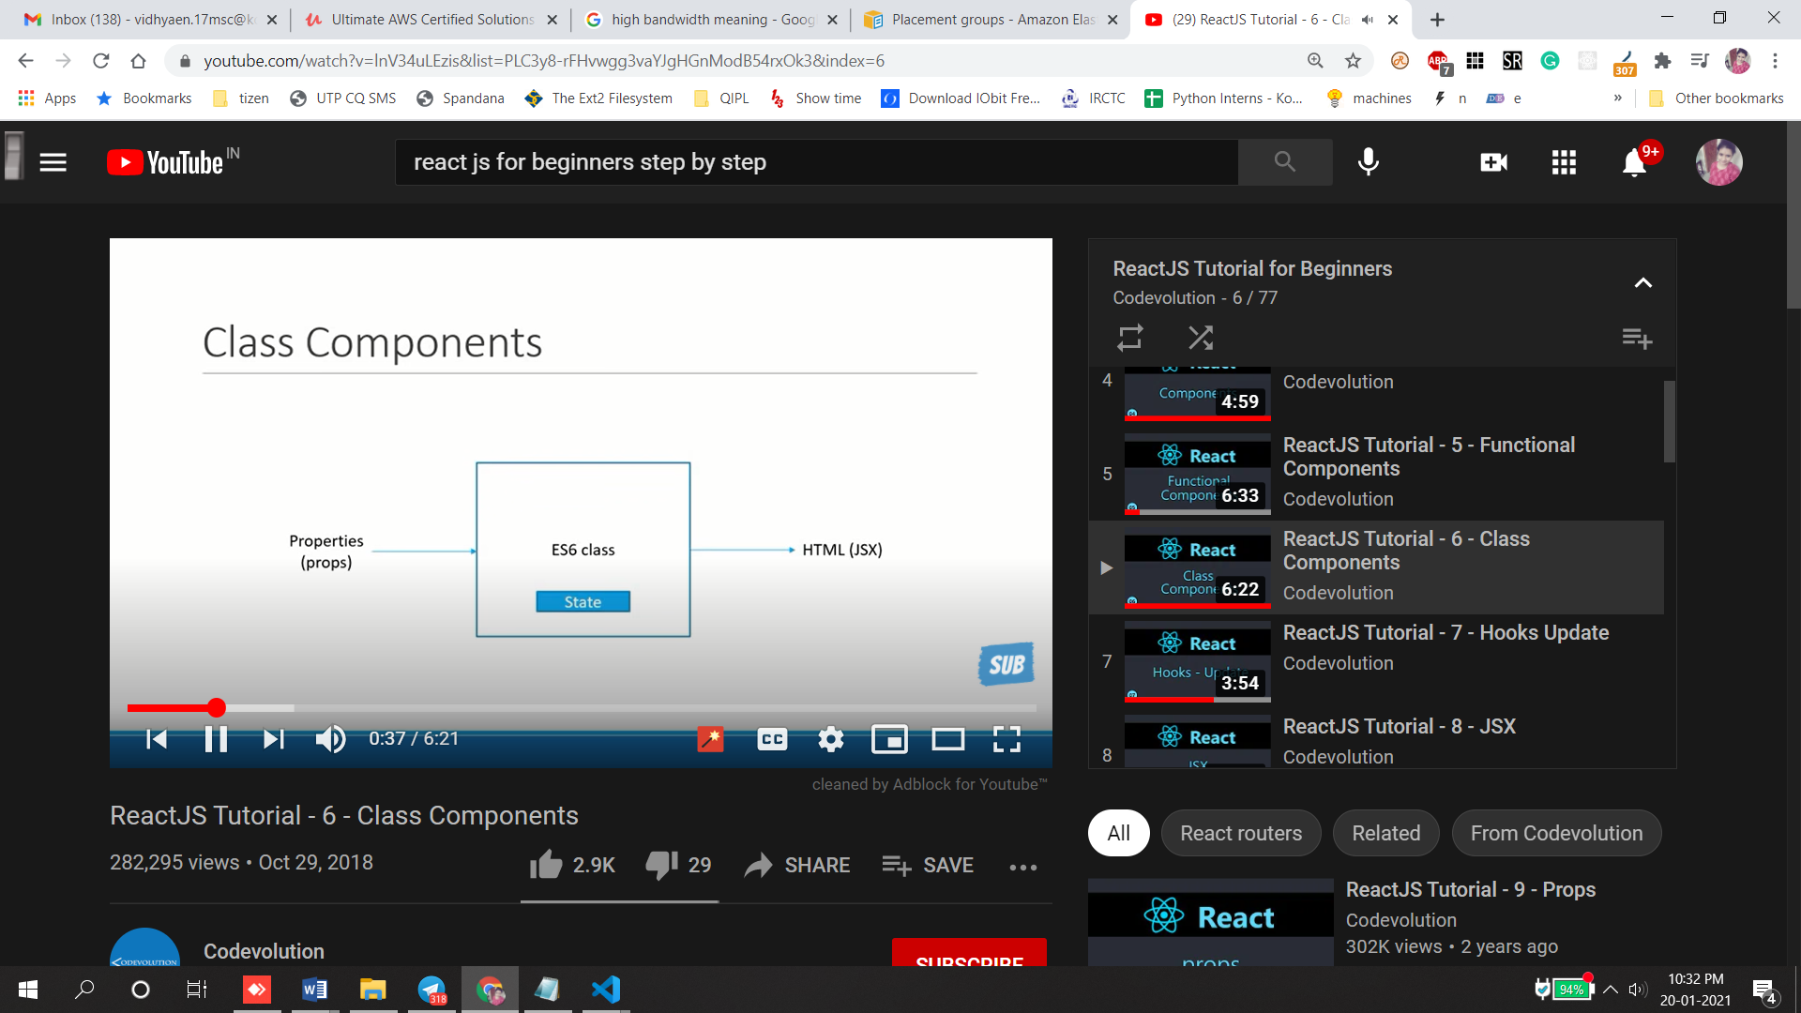

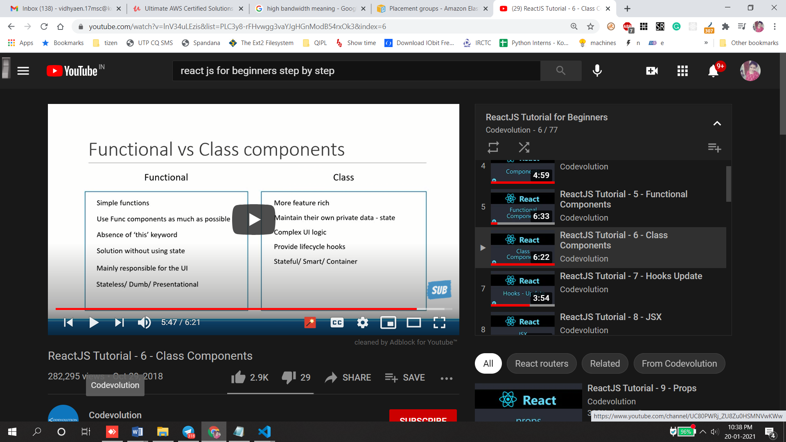

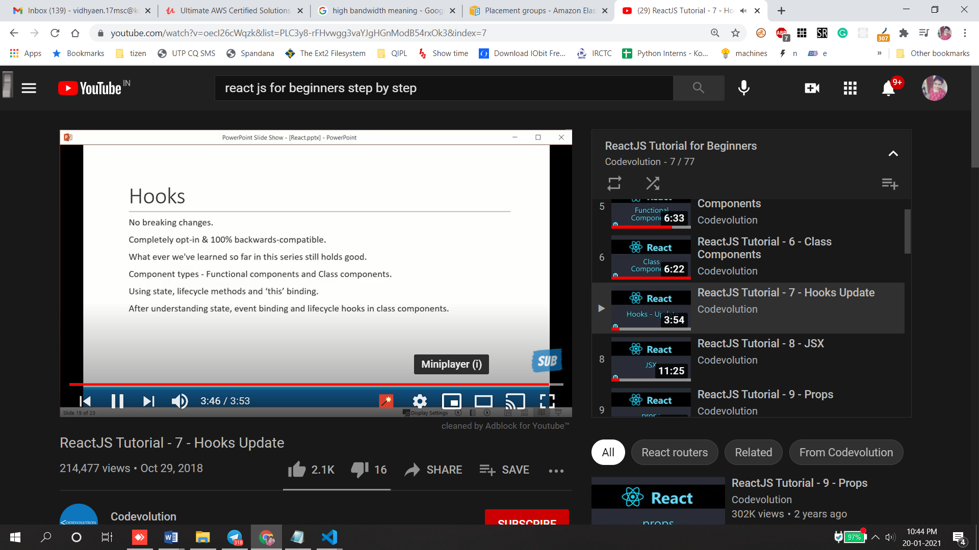

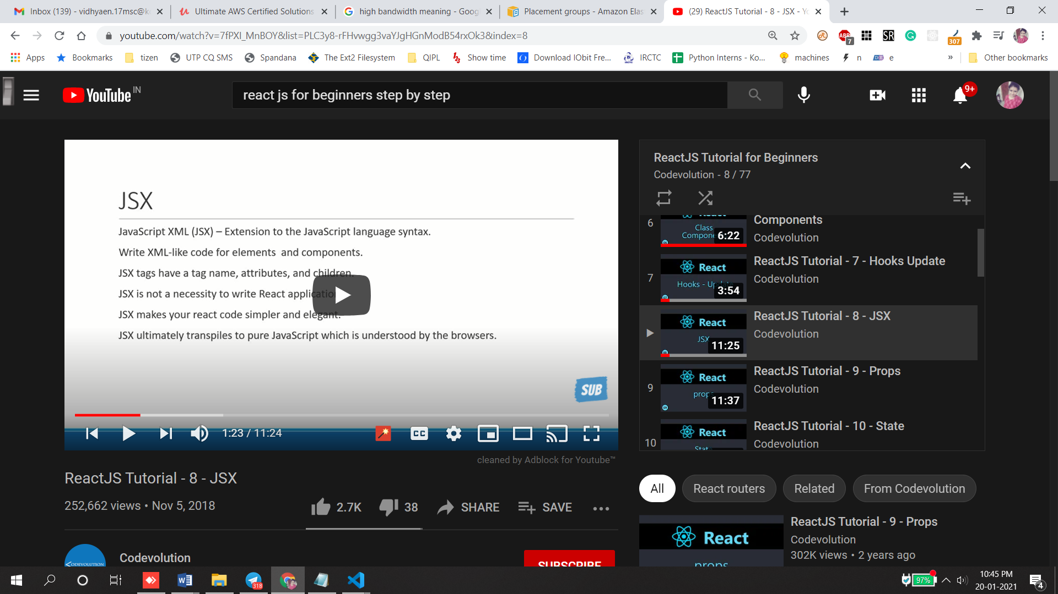

//jsx format

const Hello = () =>{

    return

(  <div className="dummyClass">

 <h1>Hello vidhu this is jsx </h1>

    </div>

)}

//without using jsx

const Hello = () =>{

return React.createElement(

   'div',{id :'hello',className:'dummyClass'},

     React.createElement('h1',null,'hello vidhu')

 )}

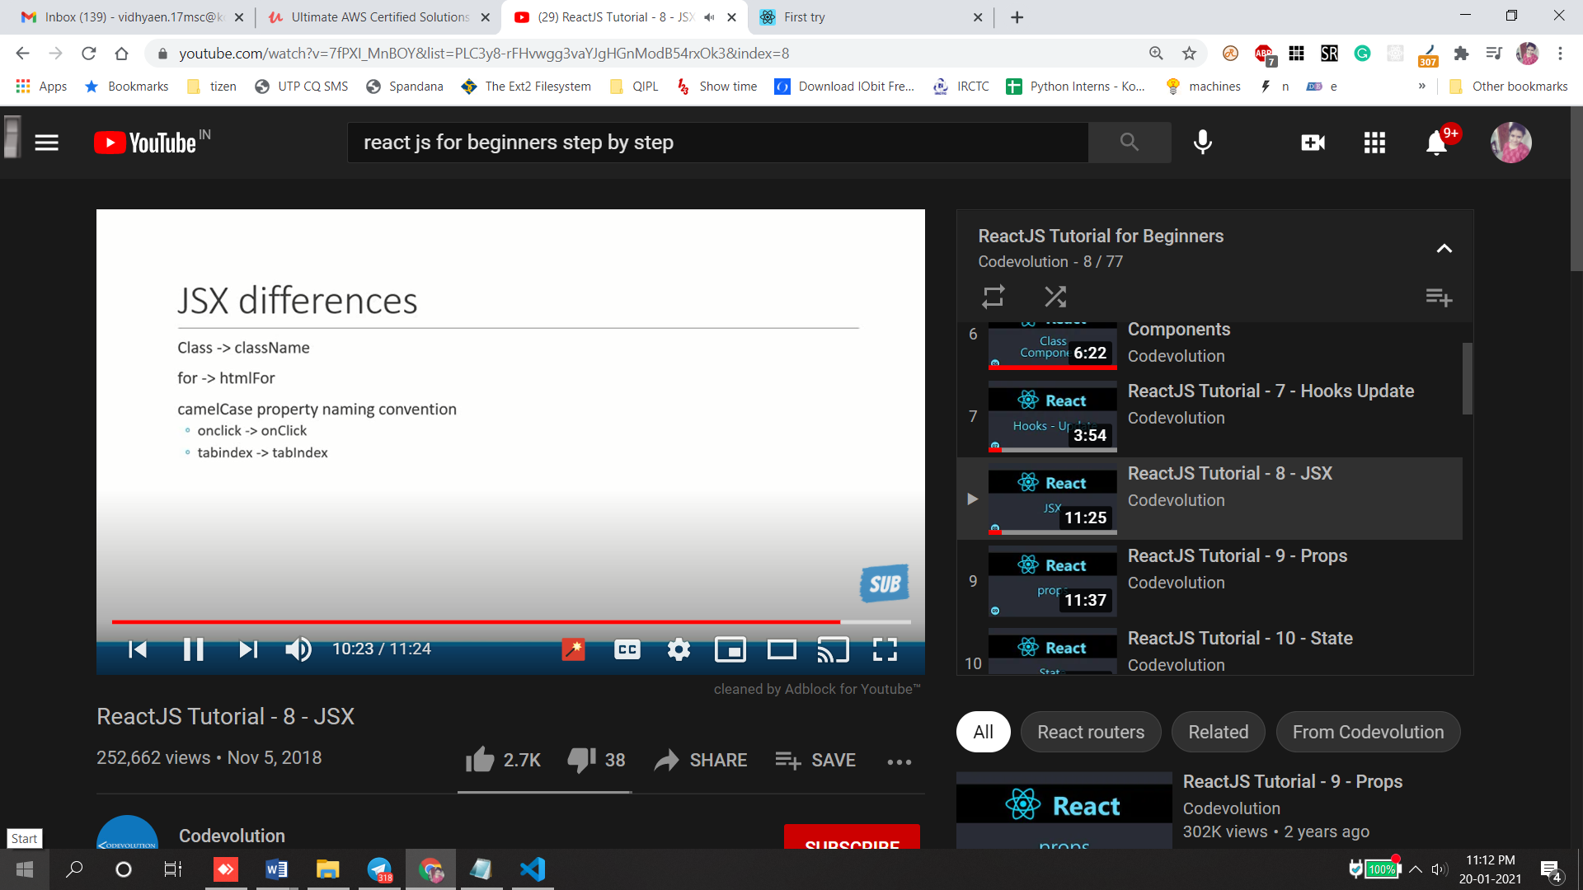 https://github.com/facebook/react/issues/13525

Props: optional input that your component accepts, also allows component dynamic. Props are immutable.

React need to act as pure func with respective props parameter

Functional component

App.js

 <Hello name="pranesh">

      <p>this children props</p></Hello>

      <Hello name="prem">

        <button>Action</button>

     </Hello>

Hello.js

const Hello =props =>{

    return(

         <div className="dummyClass">

<h1>Hello  {props.name}

</h1>

{props.children}

 </div>

Class component:

class Hi extends Component {

    render(){

        return <h1>Class components {this.props.name}</h1>

    }

}

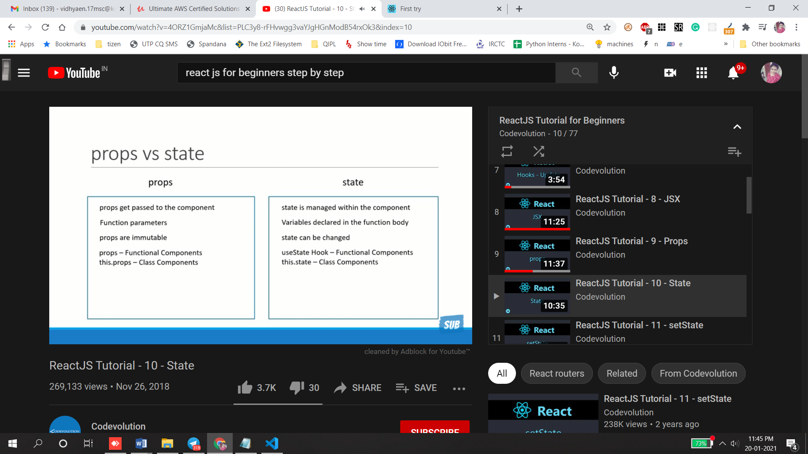

State: it has ability to change the message but props cannot change

Return() parenthese need bcz need to add multiple lines in div tag bcz react wants to return only one element.

class Message extends Component{

constructor()

{

    super() //this required bcz we extend react class component n call has to made to the base class constructor

    this.state={

        Message:'Welcome vistor'

    }

}

changeMessage()

{

#this method accepts obj which is nothing but new state of the component

    this.setState(

        {

           Message: 'Thank you for subscribing'

})

}

render()

{

    return(

        <div>

            <h1>{this.state.Message}//bind the this value in render()</h1>

            <button onClick={()=>this.changeMessage()}> Subscribe</button>

        </div>

    )

}

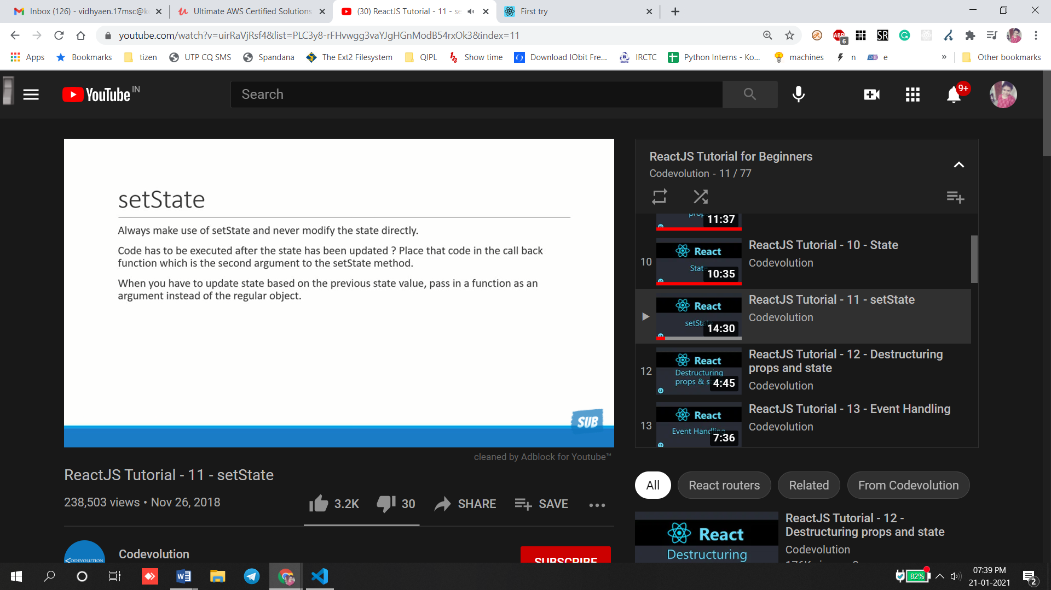

It has 2 parameter state object ,second one is callback

Rcc is short form create class component in es6

import React, { Component } from 'react'

export default class counter extends Component {

constructor(props)

{

Super(props)

{

this.state({

Count:0

})

}

increment()

{

This.setState({

Count:this.state.count+1

})}

    render() {

       return (

          <div>

            <div>Count{this.state.count} </div>

<button onClick=()=>{this.increment()}>Increment</button>

          </div>

        )

    }

}

#this.state.count=this.state.count+1 it will not change count value.

#this.Setstate.count=this.state.count+1 it will increment value by 1.

#complex function below code will not change the callback value so we going to use previous state props to get count value increment by 5

incrementfive()

{

Increment()

Increment()

Increment()

Increment()

Increment()

}

Increment()

{

This.setState(prevState =>{

Count:this.prevState.count+1

}

})}

<div>

  <div>Count{this.state.count} </div>

<button onClick=()=>{this.incrementfive()}>Increment</button>

  </div>

Destructing:

1st way:destructure in functional parameter

const Hello =({name}) =>{

    return(

  <div className="dummyClass">

{/* destructing props value */}

<h1>Hello  {name}

</h1></div>)

2 way:to destructure the functional body

const Hello =props =>{

const {name}=props #extract name from props object

    return(

  <div className="dummyClass">

{/* destructing props value */}

<h1>Hello{name}

</h1></div>)

class Hi extends Component {

    render(){

const {name}=this.props

// const {state1)=this.state

        return <h1>Class components {this.name}</h1>

    }

}

Event handler:

Should be camalcase,it is a handler not a function call so remove()

1)function FunctionClick() {

   function clickhandler()

    {

        console.log('clickmee');

    }

    return (

        <div>

              <button onClick={clickhandler}>Click me</button>

            </div>

    )

}

2) class ClassClick extends Component {

    clickhandler()

    {

        console.log('buttonclicked');

    }

    render() {

        return (

            <div>

                <button onClick={this.clickhandler}>Click me</button>

            </div>

        )

    }

}

Event binding :

It has 4 approach

We use event binding it is same like we using keyword as this in js

This keyword is undefined in event handler so we use event binding it is neccassary in react class component

1 and 2 approach has performance implication

3r d n 4th best way but 3rd one is official one it will bind event handler in the constructor

class EventBind extends Component {

    constructor(props) {

        super(props)

        this.state = {

            message: 'Hello'

        }

        //binding class constructor: this.clickHandler=this.clickHandler.bind(this)

    }

    // clickHandler()

    // {

    //     this.setState({

    //         message:'goodbyee'

    //     })

    // }

    //arrow func as base property

    clickHandler = () =>{

     this.setState(

         {

            message:'goodbyee'

         }

     )

    }

    render() {

        return (

            <div>

                <div>{this.state.message}</div>

                {/* approach 1: binding in render performace implication <button onClick={this.clickHandler.bind(this)}>Click</button> */}

               {/*approach 2 arrow func in render <button onClick={()=>this.clickHandler()}>Click</button>

               best approach 3 binding class constructor<button onClick={this.clickHandler}>Click</button>

                <button onClick={}>Click</button>

                final approach arrow function as base property*/}

               <button onClick={this.clickHandler}>Click</button>

            </div>

        )

    }

}

**Method as props:**

**What if child component wants to communicate with parent component strangely we use props but this time we pass reference as method to props as child component**

**$`` -template literal is a feature of es6 but not a feature of react.**

Template literals are string literals allowing embedded expressions. You can use multi-line strings and string interpolation features with them.

Short form :rce –class comp ,rconst-class const with super(),rcfe-functional com

Example :Method as props:

Parent component state is defined in class constructor as arg as props after greetaparent method display alert name with template literal from that we have to bind state in class constructor with greetparent after that we need to create child component.Func Comp of child component will have button with handler it will access as props of parent component.

Parent.js

import React, { Component } from 'react'

import Child from './Child'

export class Parent extends Component {

    constructor(props) {

        super(props)

        this.state = {

             ParentName:'Parent'

        }

        this.greetParent=this.greetParent.bind(this)

    }

    greetParent()

    {

        alert(`Heloo ${this.state.ParentName}`)

    }

    render() {

        return (

            <div>

                <Child greetHandler={this.greetParent}/>

            </div>

        )

    }

}

export default Parent

Child.js

import React from 'react'

function Child(props) {

    return (

        <div>

  Access method as props object

            <button onClick={props.greetHandler}>greetParent</button>

        </div>

    )

}

export default Child

how to pass parameter when calling parent methods from child Components

we use arrow func

function Child(props) {

    return (

        <div>

  {/* //pass paraamter  calling from parent to click use arrow function */}

            <button onClick={() => props.greetHandler('child')}>greetParent</button>

        </div>

    )

**}**

**Parent.js**

 greetParent(childName)#pass child in greetparent

    {

        alert(`Heloo ${this.state.ParentName} from ${childName}`)

    }

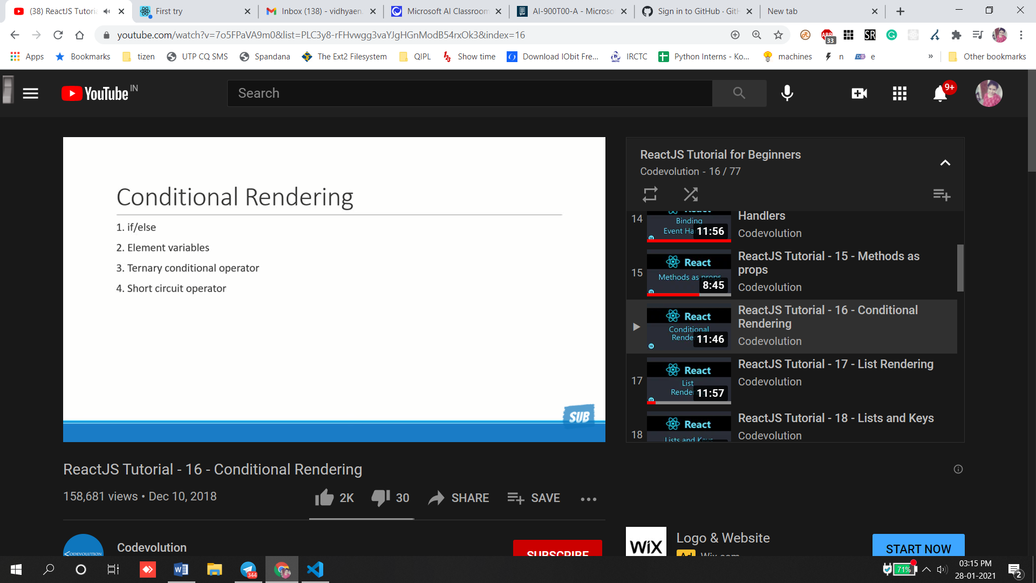

**If else method don’t work inside jsx bcz it is syntactic sugar for functional calls and object construction**

**Better approach using js method to store elements**

**If condition rendered:**

import React, { Component } from 'react'

export class Condition extends Component {

    constructor(props) {

        super(props)

        this.state = {

             isLogined:false

        }

    }

    render() {

**// 1st approach if/else**

 if(this.state.isLogined)

 {

     return <div>Welcome vidhu </div>

 }

else{

  return  <div>Welcome ananomous</div>}

**//2nd approach element variables: message is variable to render**

         let message

        if(this.state.isLogined){

           message= <div>Welcome vidhu</div>

        }

        else{

          message=  <div>Welcome ananomous</div>

         }

**// // 3rd approach ternary condition**

        // return (

        //     this.state.isLogined ?

        //     <div>Welcome vidhu</div> :

        //     <div>Welcome ananomous</div>

        //     // <div>

        //     //     {/* {message} */}

        //     // </div>

        // )

**// 4th approach short circuit when you want todo either something or nothing use this**

**// if it is true righthand is evaluted or if it is false it will never go to righthand instead it return nothing**

        return this.state.isLogined && <div>Welcome vidhu</div>

    }

}

export default Condition

**Best approach is ternary or shortcircuit it is much more clean n readable**

**List rendering:**

**Going render items in array.**

**Map() used to quickly retrieve array return new array with desire changes.**

function List() {

    const names= ['vichu','unni','malu']

    // keeping return simple use by moving out list rendering logic

    const nameList= names.map(name => <h2>{name}</h2>)

    return (

        <div>{nameList}</div>

        // <div>

        //     {

        //     // names.map(name => <h2>{name}</h2>)

        //     }

        // </div>

    )

}

export default List

List array

1)function list(){

const persons=[

        {

            id:1,

            name:'vidhu',

            age:21,

            skill:'Vue js',

        },

        {

            id:2,

            name:'Prane',

            age:21,

            skill:'React js',

        },

    ]

    const PersonList= persons.map(person =>(

<h2>I am{person.name}. {person.age} year's old. {person.skill}</h2>

    ))

    return (

          <div>{PersonList}</div>

    )

}}

**if we need to refactor jsx into separate component .**

**it is responsible for rendering list**

**list.js**

2)const persons=[

        {

            id:1,

            name:'vidhu',

            age:21,

            skill:'Vue js',

        },

        {

            id:2,

            name:'Prane',

            age:21,

            skill:'React js',

        },

    ]

    const PersonList= persons.map(person =><Person person={person} />)

    return ( <div>{PersonList}</div> )}

**It is responsible for rendering person component**

**Person.js**

function Person({person}) {

    return (

        <div>

            <h2>I am{person.name}. {person.age} year's old. {person.skill}</h2>

        </div>

    )

}

**Every key value should be unique for tat we using <Person key={person.id} person={person}/>**

**Key props is special attribute need to include when creating lists of element.**

**Note key props in list is not accessible in child comp bcz key prop is reserved so in any your comp do not try to use key prop to render any data.**

**Key props uses: help react to identify which items in list have to changed or added or remove and place crucial role handling Ui updates efficiently.**

**React update the iteration over same time and generates mutation whenever there is difference**

**Example react matches with first item in the list and sees there is no difference and 2nd item in the list no differenece and 3rd item in list there is difference instead they insert element in Dom tree instead of tearing old tree building new tree inesrt the item in the end of list**

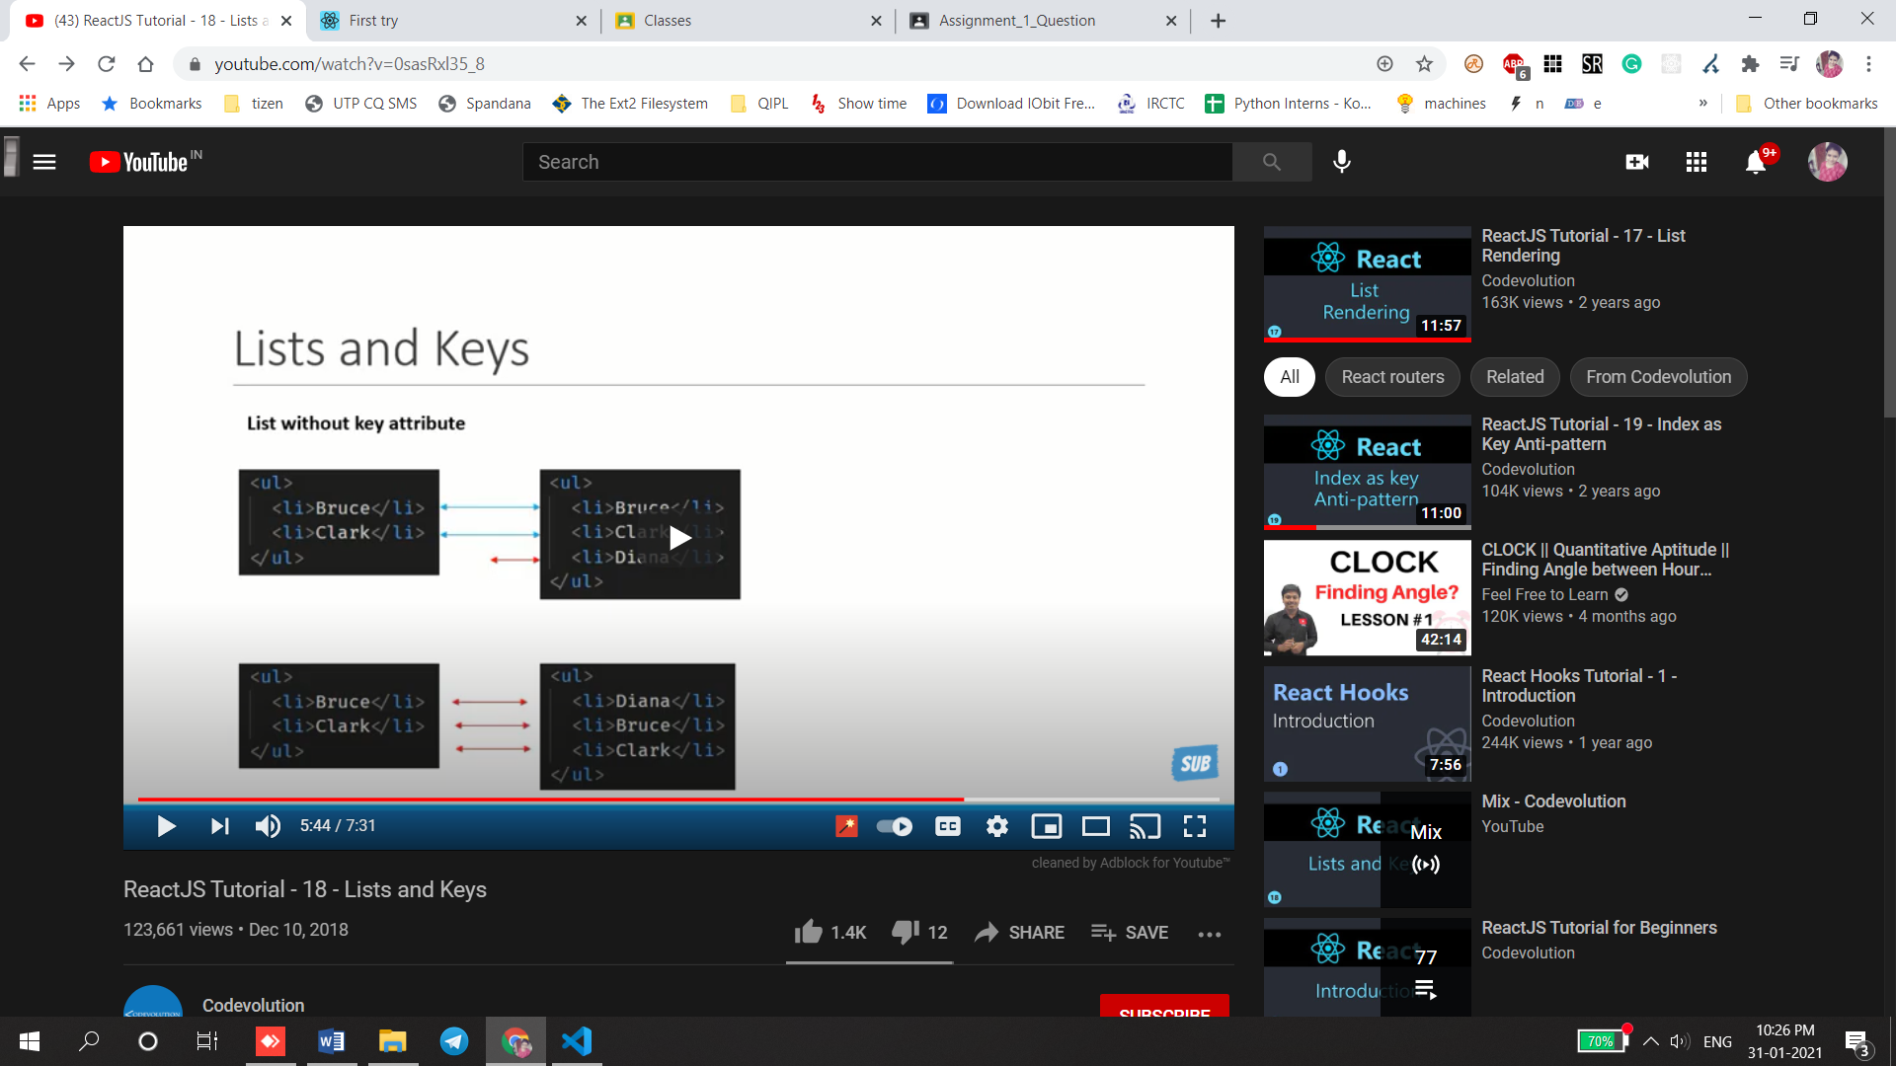

**React will compare with each item it finds that every item in the list is different.**

**It will end up mutating every the child instead of realizing it can keep bruce and clark as subtree intact.it will have inefficiency.**

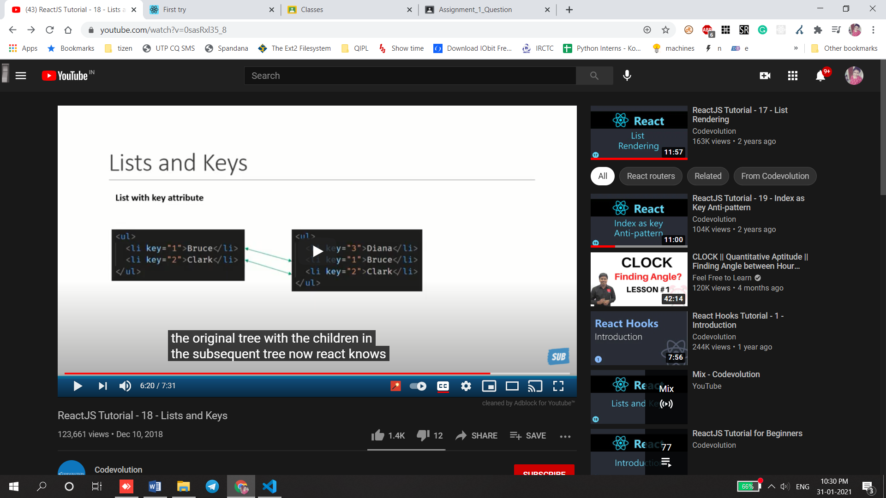

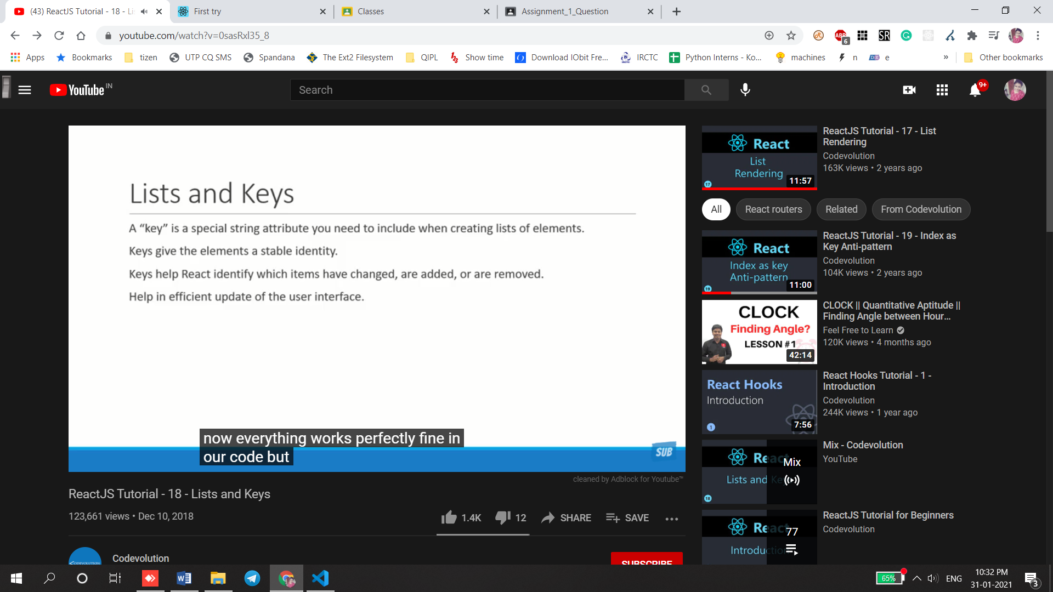

**Index as key in anti pattern:**

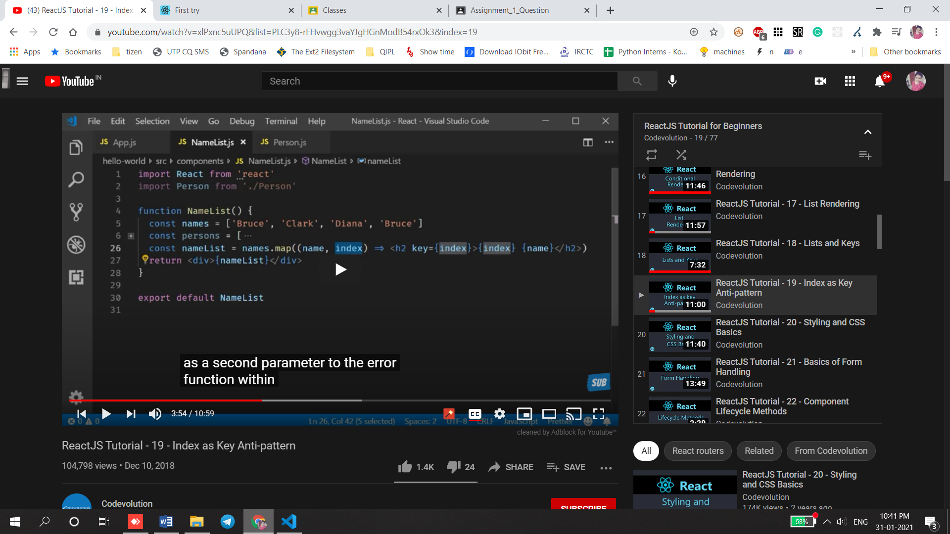

Index is used as value to the key prop

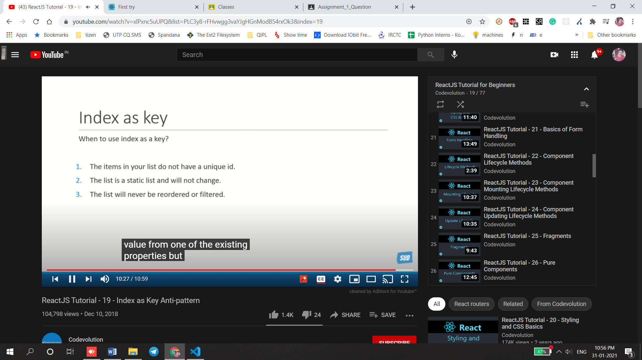

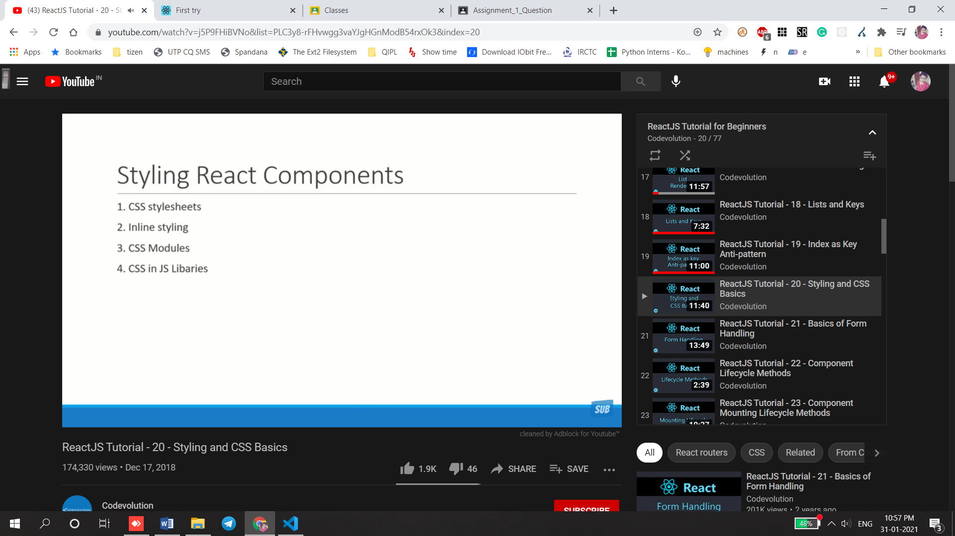

Css stylesheet

App.js

<Stylesheet primary= {true}/>

Style.cs

.primary{

    color:purple;

}

.fontxl{

    font-size: 72px;

}

Stylesheet.js

import React from 'react'

import './style.css'

function Stylesheet(props) {

    let className =props.primary ?'primary' : ' '

    return (

        <div>

            <h1 className={`${className} fontxl` }>Styesheet</h1>

        </div>

    )

}

Inline

const heading={

    fontSize:'72px',color:'blue'

}

function Inline() {

    return (

        <div>

            <h1 style={heading}>Inline</h1>

        </div>

    )

}

Css component

Adv:It is locally scoped

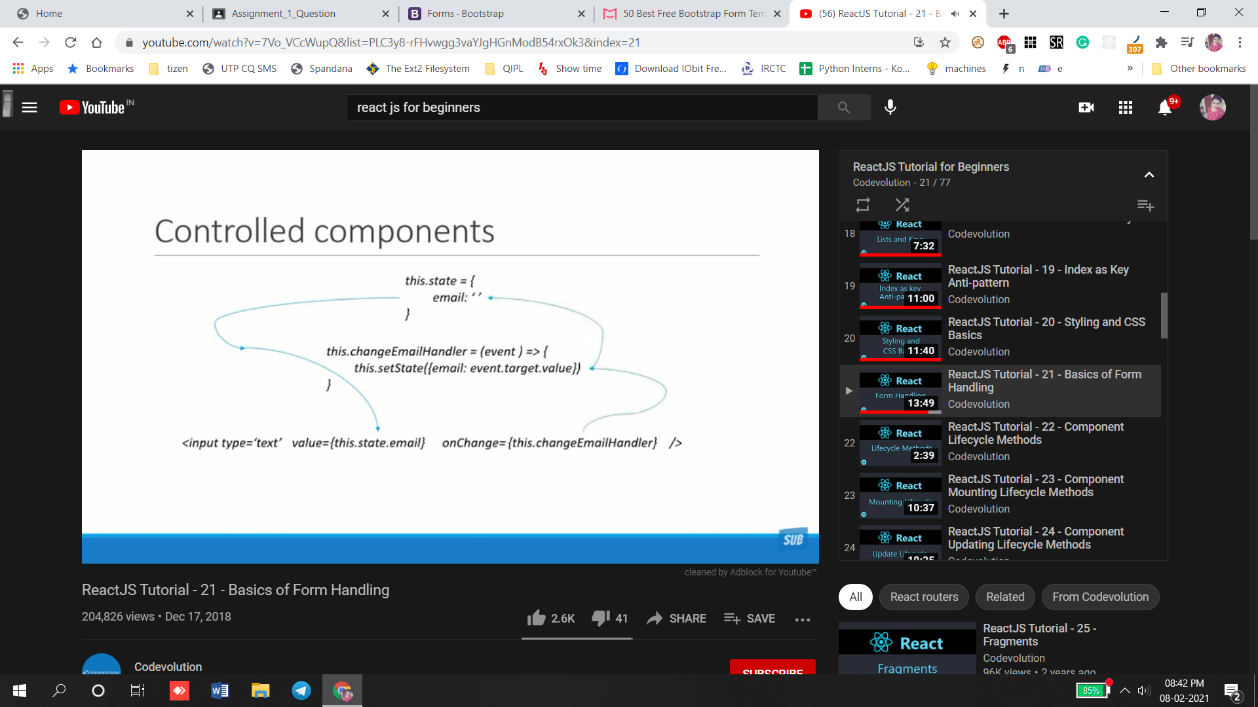

class Form extends Component {

    constructor(props) {

        super(props)

        this.state = {

             username:''

        }

    }

    handlerUsernameChange =(event) =>{

        this.setState(

            {

                username:event.target.value

            }

        )

    }

    render() {

        return (

            <div>

                <form>

                    <div>

                    <h1 className="text-danger">Login form</h1><br></br>

                    <label className="form-control p-2">Username</label>

                    <input type="text" value={this.state.username} onChange={this.handlerUsernameChange} className="form-control p-2"/>

                    <button type="submit" className="btn btn-success">Login</button>

                    </div>

                </form>

            </div>

        )

    }

}

Create component for text area n selected area Simple 3 steps:

Add html element and assign the component state to element value assign unchanged handler that updates

class Form extends Component {

    constructor(props) {

        super(props)

        this.state = {

             username:'',

             comment:'',

             topic:'react'

        }

    }

    handlerUsernameChange =(event) =>{

        this.setState(

            {

                username:event.target.value

            }

        )

    }

    handlerComment=(event) =>{

        this.setState(

            {

                comment:event.target.value

            }

        )

    }

    handlerSelect =(event) =>{

        this.setState(

            {

                topic:event.target.value

            }

        )

    }

    handlersubmit =(event) =>{

        alert(`${this.state.username} ${this.state.comment} ${this.state.topic}`)

        event.preventDefault() //this method will stay in the field after refreshing also

    }

    render() {

        return (

            <div>

                <form onSubmit={this.handlersubmit}>

                    <div>

                    <h1 className="text-danger">Login form</h1><br></br>

                    <label className="p-2">Username</label>

                    <input type="text" value={this.state.username} onChange={this.handlerUsernameChange} className="form-control p-2"/>

                    </div>

                 <div>

                     <label>Comments</label><br></br>

                     <textarea value={this.state.comment} onChange={this.handlerComment} className="form-control p-2"></textarea>

                 </div>

                 <div>

                     <label>Framework</label><br></br>

                     <select value={this.state.topic} onChange={this.handlerSelect} className="form-control p-2">

                         <option value="react">React</option>

                         <option value="vue">Vue</option>

                         <option value="angular">Angular</option>

                     </select>

                 </div><br></br>

                 <button>Submit</button>

                </form>

            </div>

        )

    }

}

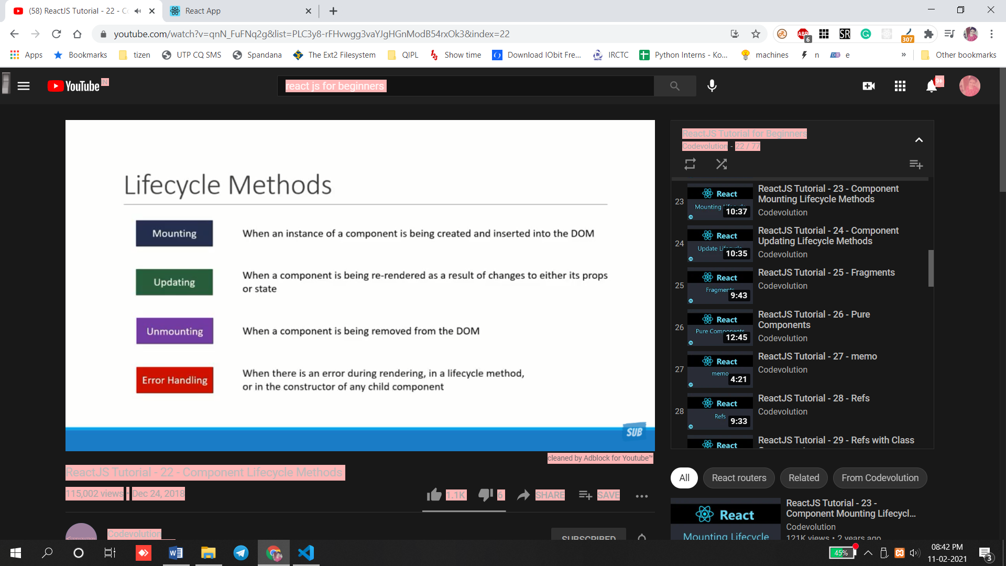

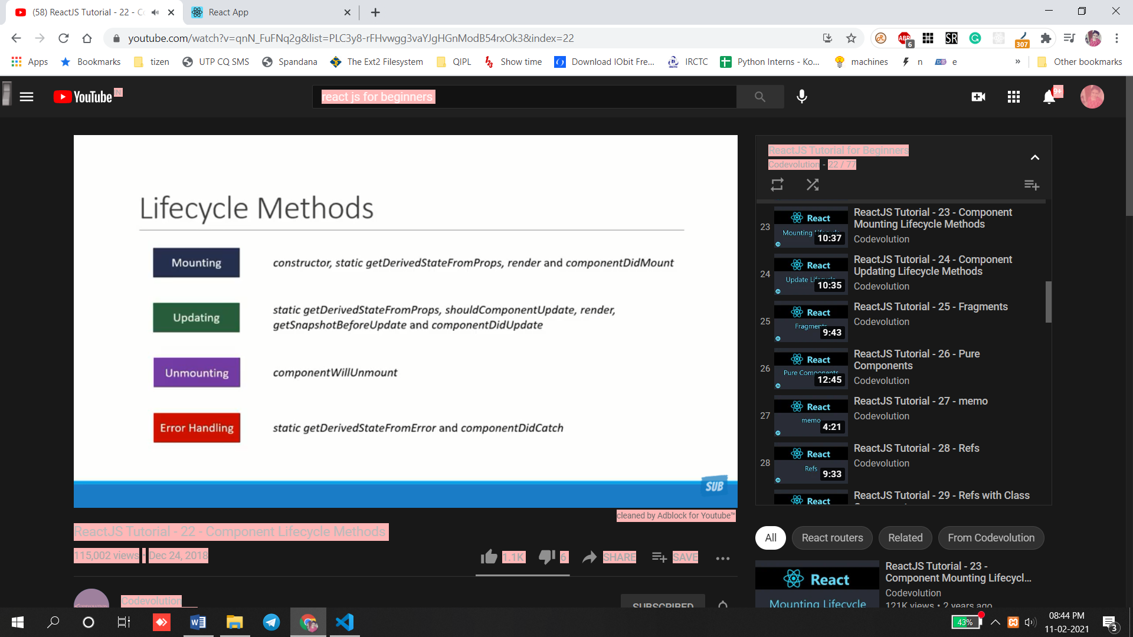

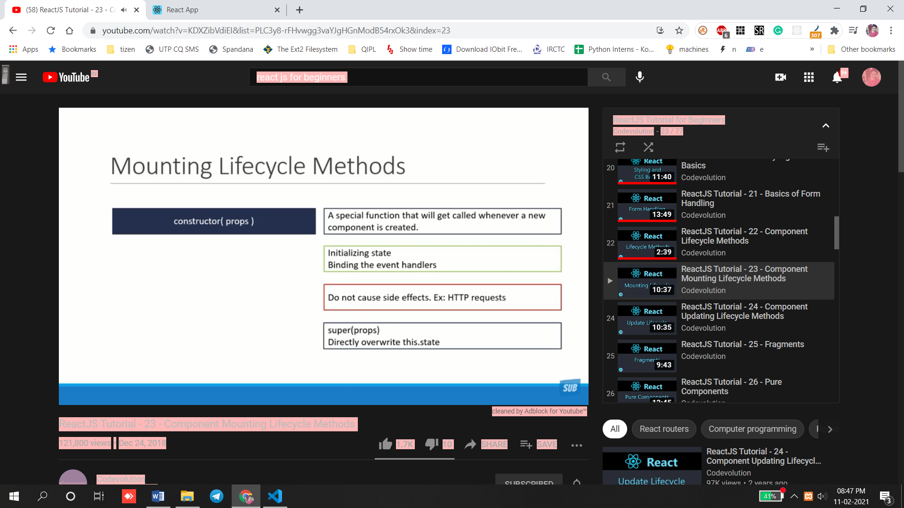

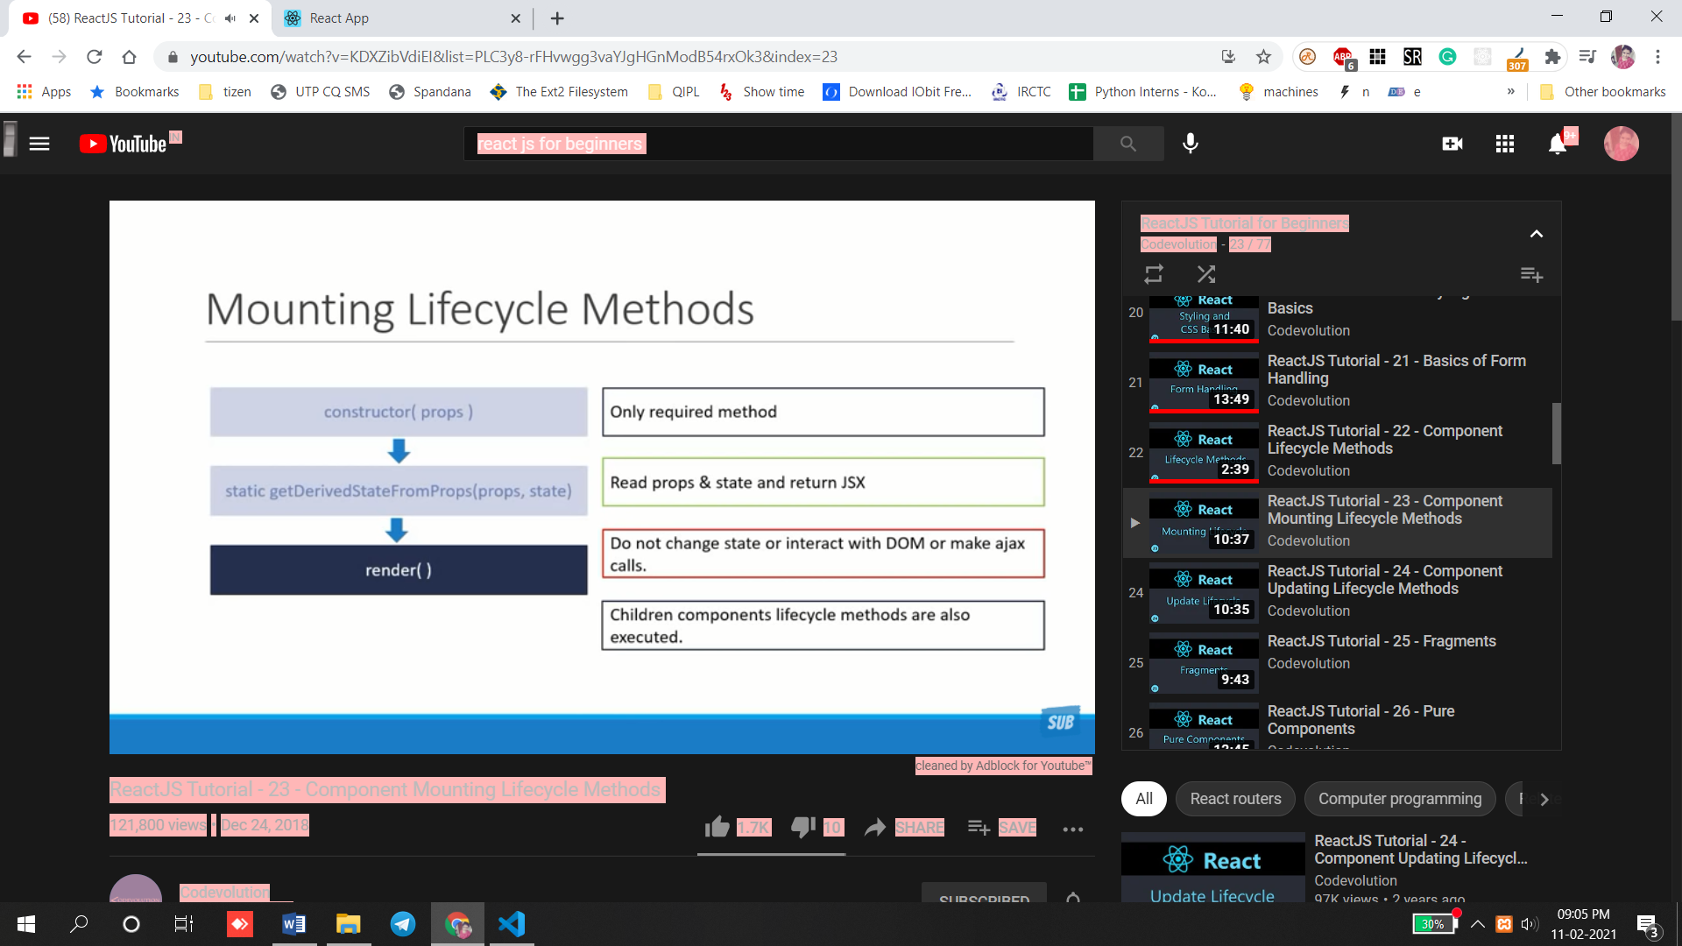

import React, { Component } from 'react'

import LifeCycleB from './LifeCycleB'

export default class LifeCycleA extends Component {

  constructor(props) {

      super(props)

      this.state = {

           name:'vidhu'

      }

      console.log('LifecyceleA constructor')

  }

  static getDerivedStateFromProps(state,props)

  {

      console.log('getdervied lifecycleA')

      return null

  }

  componentDidMount()

  {

      console.log('Didmount A')

  }

    render() {

        console.log('lifecycle A render')

        return (

            <div>

                LifecyceleA

                            </div>

        )

    }

}

Order of execution:

LifecyceleA constructor'

'getdervied lifecycleA

'lifecycle A render'

'Didmount A'

import React, { Component } from 'react'

import LifeCycleB from './LifeCycleB'

export default class LifeCycleA extends Component {

  constructor(props) {

      super(props)

      this.state = {

           name:'vidhu'

      }

      console.log('LifecyceleA constructor')

  }

  static getDerivedStateFromProps(state,props)

  {

      console.log('getdervied')

      return null

  }

  componentDidMount()

  {

      console.log('Didmount ')

  }

    render() {

        console.log('lifecycle A render')

        return (

            <div>

                LifecyceleA

                <LifeCycleB/>

            </div>

        )

    }

}

import React, { Component } from 'react'

export default class LifeCycleB extends Component {

  constructor(props) {

      super(props)

      this.state = {

           name:'vidhu'

      }

      console.log('LifecyceleB constructor')

  }

  static getDerivedStateFromProps(state,props)

  {

      console.log('getdervied B')

      return null

  }

  componentDidMount()

  {

      console.log('Didmount B')

  }

    render() {

        console.log('lifecycle B render')

        return (

            <div>

                LifecyceleB

            </div>

        )

    }

}

Order of execution

LifecyceleA constructor

LifeCycleA.js:15 getdervied

LifeCycleA.js:23 lifecycle A render

LifeCycleB.js:10 LifecyceleB constructor

LifeCycleB.js:14 getdervied B

LifeCycleB.js:22 lifecycle B render

LifeCycleB.js:19 Didmount B

LifeCycleA.js:20 Didmount

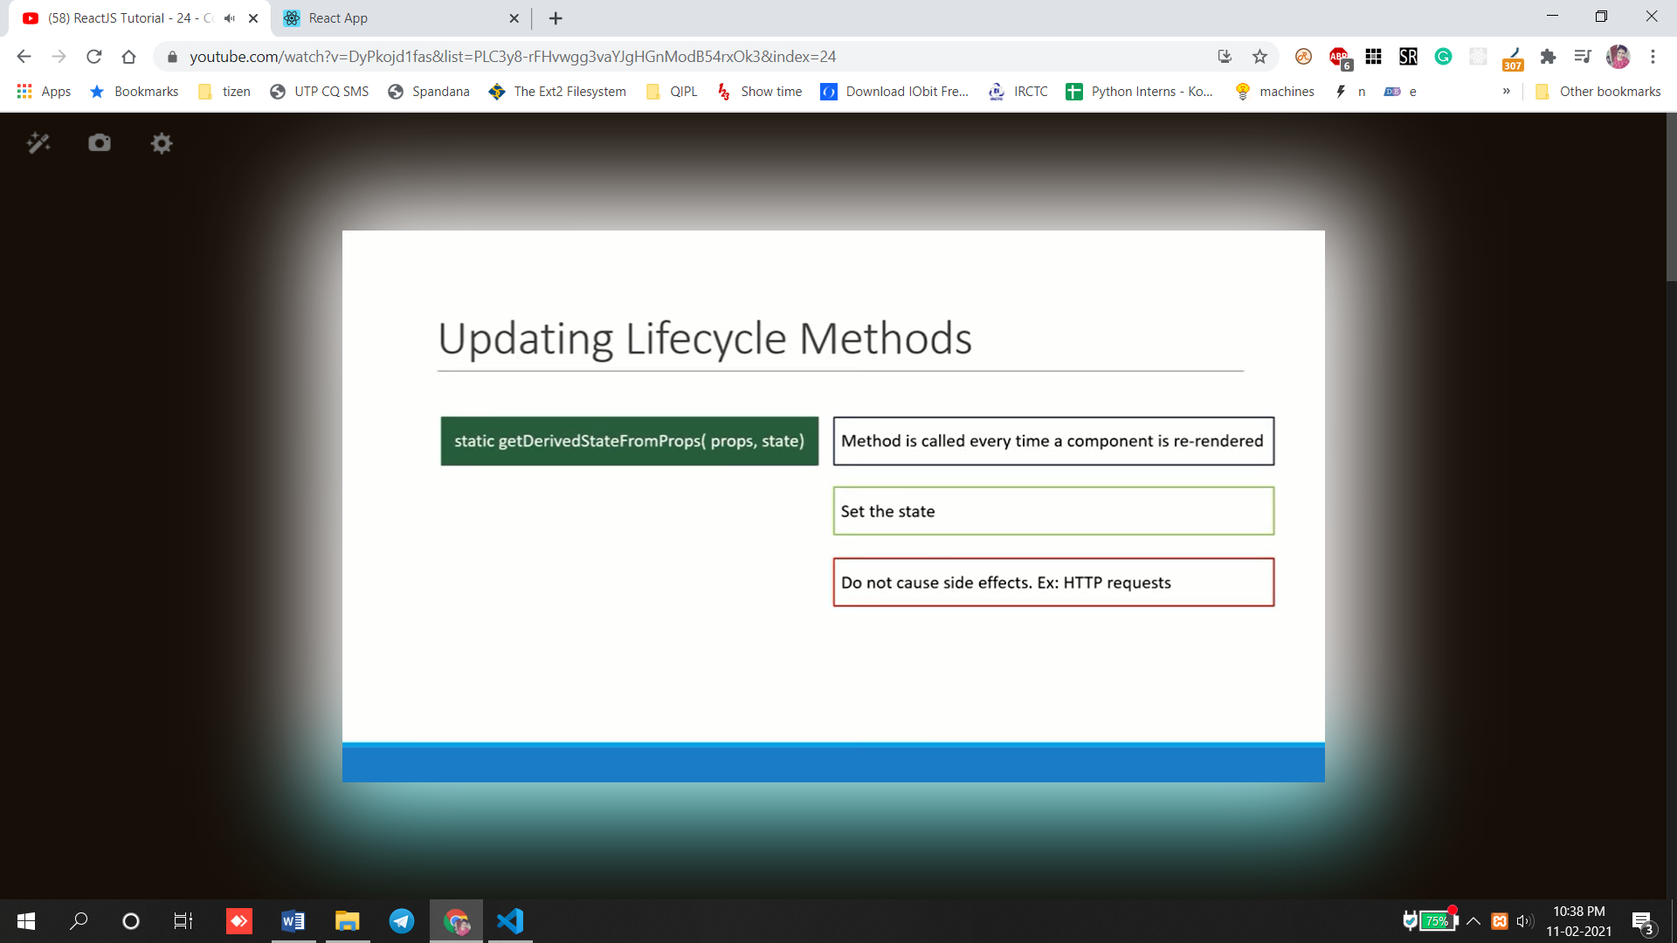

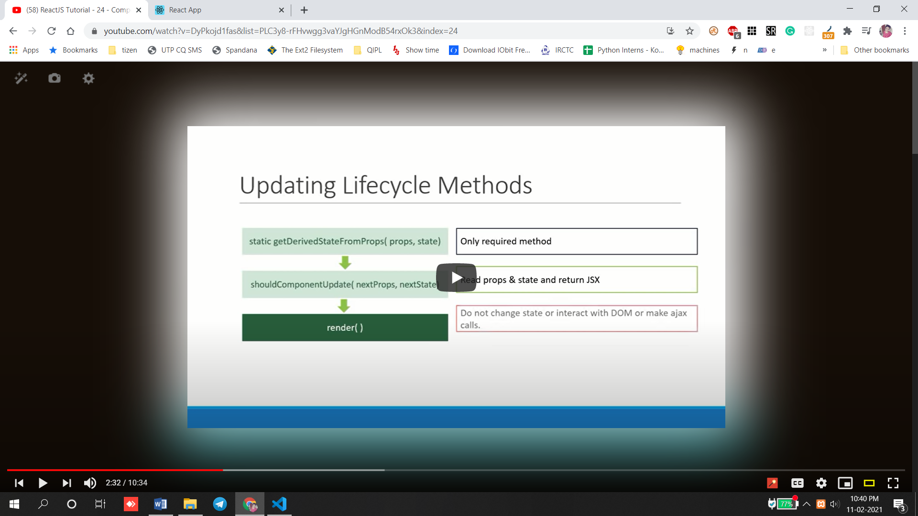



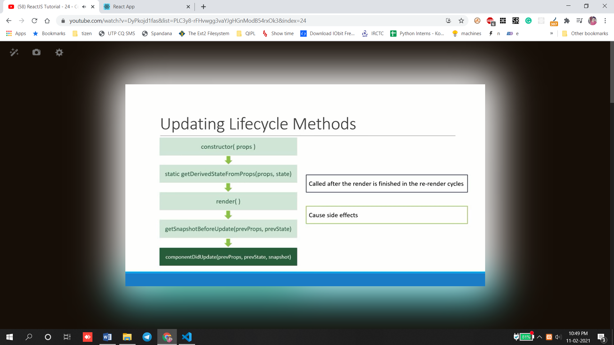

import React, { Component } from 'react'

import LifeCycleB from './LifeCycleB'

export default class LifeCycleA extends Component {

  constructor(props) {

      super(props)

      this.state = {

           name:'vidhu'

      }

      console.log('LifecyceleA constructor')

  }

  static getDerivedStateFromProps(state,props)

  {

      console.log('getdervied')

      return null

  }

  componentDidMount()

  {

      console.log('Didmount A')

  }

  shouldComponentUpdate()

  {

      console.log('shouldComponent UpA')

      return true

  }

  getSnapshotBeforeUpdate(prevProps,prevState)

  {

      console.log('Beforeupdate A')

      return null

  }

  componentDidUpdate()

  {

      console.log('component didUpdateA')

  }

 changeState = () =>{

     this.setState(

         {

             name:'evolution'

         }

     )

 }

    render() {

        console.log('lifecycle A render')

        return (

            <div>

                <div>LifecyceleA</div>

                <button onClick={this.changeState}>change</button>

                <LifeCycleB/>

            </div>

        )

    }

}

import React, { Component } from 'react'

export default class LifeCycleB extends Component {

  constructor(props) {

      super(props)

      this.state = {

           name:'vidhu'

      }

      console.log('LifecyceleB constructor')

  }

  static getDerivedStateFromProps(state,props)

  {

      console.log('getdervied B')

      return null

  }

  componentDidMount()

  {

      console.log('Didmount B')

  }

  shouldComponentUpdate()

  {

      console.log('shouldComponent Update B')

      return true

  }

  getSnapshotBeforeUpdate(prevProps,prevState)

  {

      console.log('Beforeupdate B')

      return null

  }

  componentDidUpdate()

  {

      console.log('component didUpdateB')

  }

    render() {

        console.log('lifecycle B render')

        return (

            <div>

                LifecyceleB

            </div>

        )

    }

}

o/p

LifeCycleA.js:15 getdervied

LifeCycleA.js:24 shouldComponent UpA

LifeCycleA.js:44 lifecycle A render

LifeCycleB.js:14 getdervied B

LifeCycleB.js:23 shouldComponent Update B

LifeCycleB.js:36 lifecycle B render

LifeCycleB.js:28 Beforeupdate B

LifeCycleA.js:29 Beforeupdate A

LifeCycleB.js:33 component didUpdateB

